# High Level Design (HLD)

# Adult Census Income Prediction

**Version 1.0**

**Date of Revision 8August 2022**

**Document Version Control**

**Date Issued Version Description Author**

08-08-22 1 Initial HLD – V1.0 Gunja Kumari

# Contents

Document Version Control Abstract

1. Introduction
   1. Why this High-Level Design Document ?
   2. Scope
   3. Definitions
2. General Description
   1. Product Perspective
   2. Problem Statement
   3. Proposed Solution
   4. Technical Requirements
   5. Data Requirements
   6. Tools Used
   7. Constraints
   8. Assumptions
3. Design Details
   1. Application Process Flow
   2. Model Training
   3. Event Logs
   4. Error Handling
4. Performance
   1. Reusability
   2. Application Compatibility
   3. Resource Utilization
   4. Deployment 5 Conclusion

## Abstract

Many of the existing machine learning models for income analysis are concentrating .In this article proposing a system which used to predict Adult Census Income prediction by using Flask API. To implement Adult Income analysis used machine learning algorithms and Flask API. Python dll is used to save the model behaviour and python dll is used to load the pickle file whenever required. The importance of this article analysis in while analysing the income all the parameters is included so it possible to predict the Adult Income. For example for income analysis in many existing systems considered few parameters like age, workclass, marital_status, occupation, relationship, sex, race,capital loss, capital gain, hours per week, native country. Final models behaviour will be saved as python model file. Flask API is designed. When user accessing this API, the user has to send the parameters of the Adult . Flask API will invoke the corresponding model and returns the income of the Adult. The importance of this analysis to analyse the income .

## Introduction

### Why this High-Level Design Document ?

The purpose of this High-Level Design (HLD) Document is to add the necessary detail to the current project description to represent a suitable model for coding. This document is also intended to help detect contradictions prior to coding, and can be used as a reference manual for how the modules interact at high level.

The HLD will:

* + - Present all of the design aspects and define them in detail
    - Describe the user interface being implemented
    - Describe the hardware and software interfaces
    - Describe the performance requirements
    - Include design features and the architecture of the project
    - List and describe the non-functional attributes like:
      * Security
      * Reliability
      * Maintainability
      * Portability
      * Reusability
      * Application compatibility
      * Resource utilization
      * Serviceability

**1.2** **Scope**

The HLD documentation presents the structure of the system, such as the application architecture (layers), application flow (Navigation), and the technology architecture. The HLD uses non-technical to mildly-technical terms which should be understandable to the administrators of the system.

**1.3 Definitions**

|  |  |
| --- | --- |
| **Terms** | **Description** |
|  |  |
| IDE | Integrated Development Environment |

## General Description

### Product Perspective

The Adult Census Income prediction System is a machine learning based system

### Technical Requirements

* build a machine learning web application.
* Use uci dataset.
* Use cloud platform for deploying an application

### Data Requirements

Dataset composed of a









1. **Jupyter Notebook** has been used for EDA
2. For data cleaning and preprocessing, **Pandas** have been used.
3. **Python**, **Flask**, **Scikit Learn** use for building Machine Learning Web Application.
4. Front End Development is done using HTML, CSS.
5. **GitHub** has been used as the version control system

### Constraints

Adult Census Income prediction System must be user friendly, well maintainable.

### Assumptions

The main objective of the project is to implement use cases of Adult Income Census prediction, and finding improvement strategies.

### Design Details

* 1. **Application Process Flow**

For the Adult Census Income prediction we will use a machine learning based model. Below is the process flow diagram.

Dataset

Machine Learning Algorithm

Input

Designed Model

Prediction

Result/ Classification

### Model Training

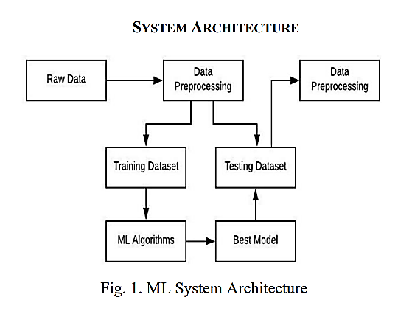

**3.1.2 Deployment process**

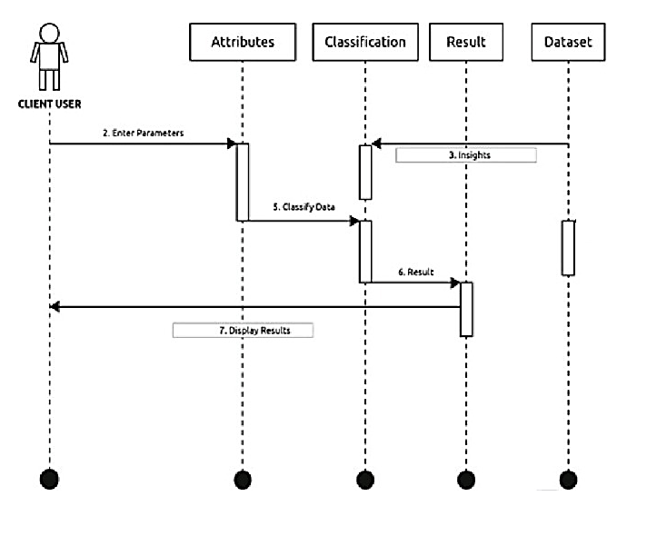

* 1. **Event Logs**

The System should log every event so that the user will know what process is running internally.

**Initial Step-By-Step Description**

* + 1. The System identifies at what step logging required
    2. The System should be able to log each and every system flow.
    3. Developers can choose logging methods. You can choose database logging/ File logging as well.
    4. System should not hang even after using so many loggings. Logging just because we can easily debug issues so logging is mandatory to do.

### Error Handling

Should errors be encountered, an explanation will be displayed as to what went wrong? An error will be defined as anything that falls outside the normal and intended usage.

### .Performance

Evaluate performance of model for Adult Census Income prediction.

### Reusability

The code written and the components used should have the ability to be reused with no problems.

### Application Compatibility

The different components for this project will be using Python as an interface between them. Each component will have its own task to perform, and it is the job of the Python to ensure proper transfer of information.

### Resource Utilization

When any task is performed, it will likely use all the processing power available until that function is finished.

### Deployment



1. **Conclusion**

Here based on the user input income will be predicted. The choice will be given to user. If the user want to predict income or if the user don’t enter any disease type then based on user entered inputs corresponding model will be invoked and predicted.